NavierStokes_1.py: ACCURACY -> 0.414

$$H_{k+1}=H_{k}+dt(νLH_{k}+F(H_{k}))$$

We have no $(u⋅∇)u$ term here, and the kinematic viscosity was limited to $ν≥0$.
The diffusion term $νLH$ or $νΔu$ makes the embeddings similar, by allowing them to be negative, we can push them apart.

NavierStokes_2.py: ACCURACY -> 0.568
Here we do not restrict the learnable viscosity to positive number. Furthermore, the learnable viscosities and forces are on the edges instead. Heterophilic connections can be between similar or dissimilar nodes, and having learnable parameters on the nodes adds restrictions.

$$H_{i}^{k+1}=H_{i}^{k}+dt\left(\sum_{j}{ν_{ij}}\left(H_{j}-H_{i}\right)+\sum_{j}{f_{θ}\left(H_{i},H_{j}\right)}\right)$$

Instead of $νLH$ we have $div(ν\left(x\right)∇H)$ here.
We do not have the nonlinear term $(u⋅∇)u$ here!
Epoch 300 | Loss: 0.0376 | Test Acc: 0.5680 -> Low loss and higher acc means overfitting
NavierStokes_3.py: ACCURACY -> 0.449
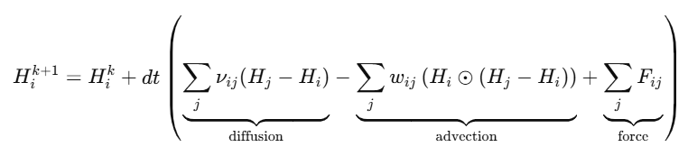
The advection term includes a multiplication that is element-wise
Here we don’t have scew symmetry $A^{T}=-A$ or $A_{ij}=-A_{ji}$ , due to the advection term and energies may rise. We will need some conservation maybe. If conservation does not work then it means that the Chameleon graph does not behave as a liquid.
Some options to continue:
- Make the diffusion into a polynomial filter, Chebychev filter. And don’t use the advection term.
- Use some spectral methods and eigenvalues????
- Add conservation terms to Navier-Stokes
Conservative form
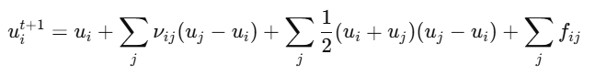
- Addition of learnable embeddings alongside the current embeddings
- A true Graph Navier-Stokes solver using edge flux tensors (finite-volume GNN)

NavierStokes_4.py: ACCURACY -> 0.377
The advection was written in a conservative form, but this did not help.


NavierStokes_5.py: ACCURACY -> TIMEOUT
As NavierStokes_2.py, but with viscosity and force tensors. This is more computationally heavy.
